# R PROGRAMMING LAB

**Week 1:**

**EXPERIMENT NO**:1(a)  **DATE:**

**Aim:** Installing R and RStudio.

**Description:**

* R is an open-source programming language and free environment that specializes in statistical computing and graphical representation.
* It is mainly used by statisticians and data miners for developing statistical software and performing data analysis.
* To use R language, you need the R environment to be installed on your machine, and an IDE (Integrated development environment) to run the language (can also be run using CMD on Windows or Terminal on Linux).

**Installing R and RStudio on Linux:**

Linux software is often distributed as source code and then compiled by package managers like apt or yum. To install R in Ubuntu, we will have to go through the following steps.

**Install R on Linux**

Install the R-base package using the following code

1. sudo apt-get update.

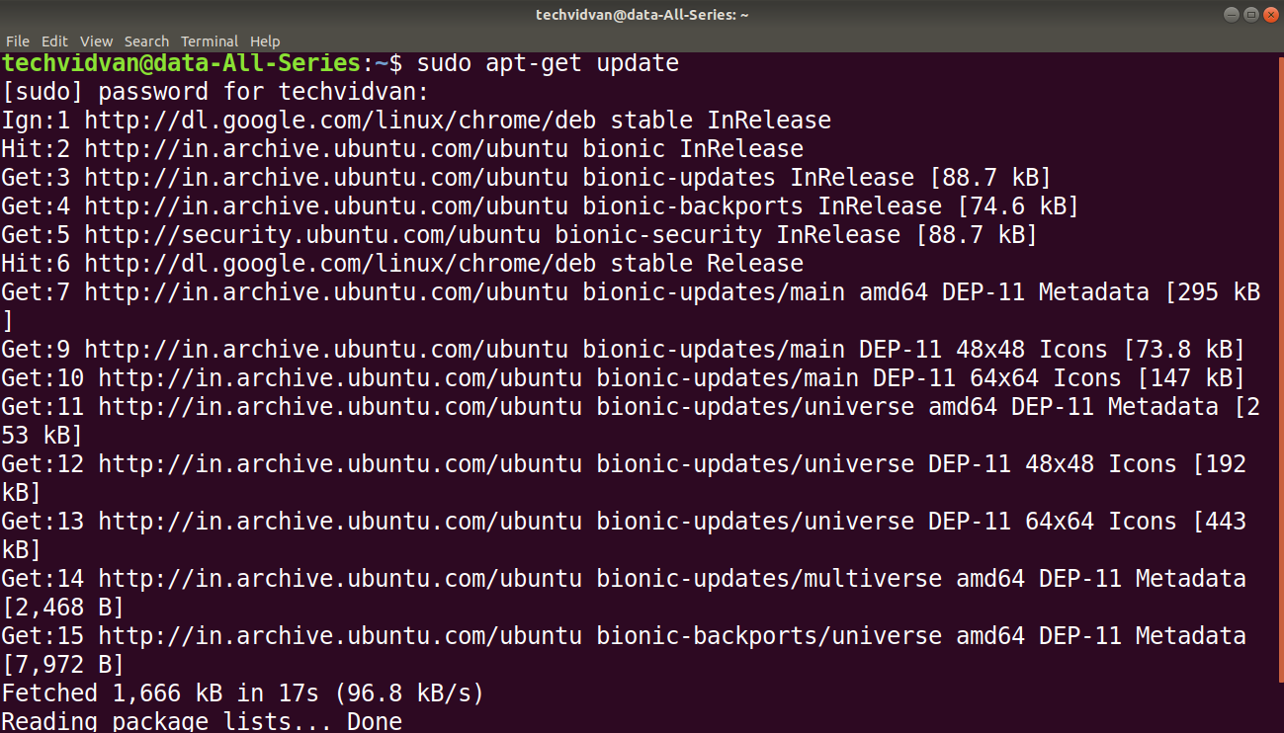

* sudo apt-get install r-base

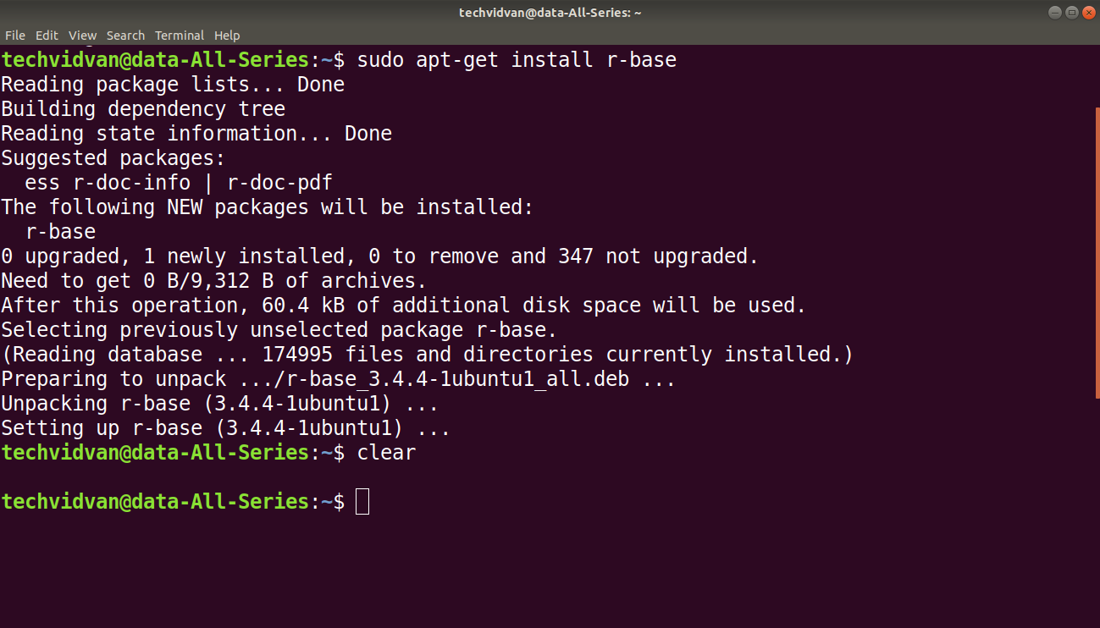

* After running the command, a confirmation prompt will appear. Answer it with a ‘Y’ for yes.

#### Install RStudio on Linux

**Step – 1**Next comes installing RStudio. To install RStudio, go to [download RStudio](https://www.rstudio.com/ide/download), click on the download button for RStudio desktop, click the link for the latest R version for your OS and save the .deb file.

**Step – 2**Download and install the **gdebi** package using the following commands.

* sudo apt install gdebi

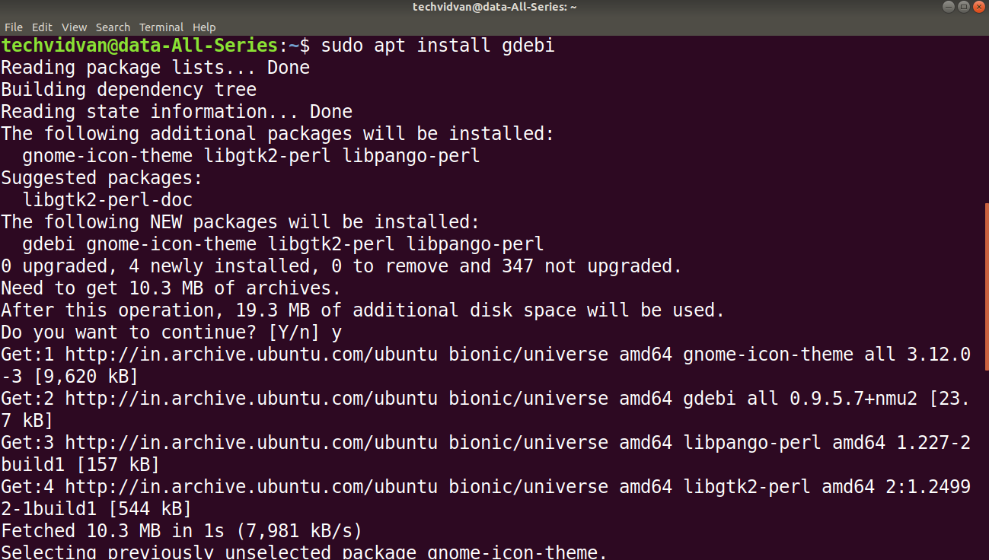

* Answer with a ‘Y’ for yes to confirm when prompted.

**Step – 3**: Use the following commands to install the .deb package

* sudo gdebi /path/to/the/file/.deb

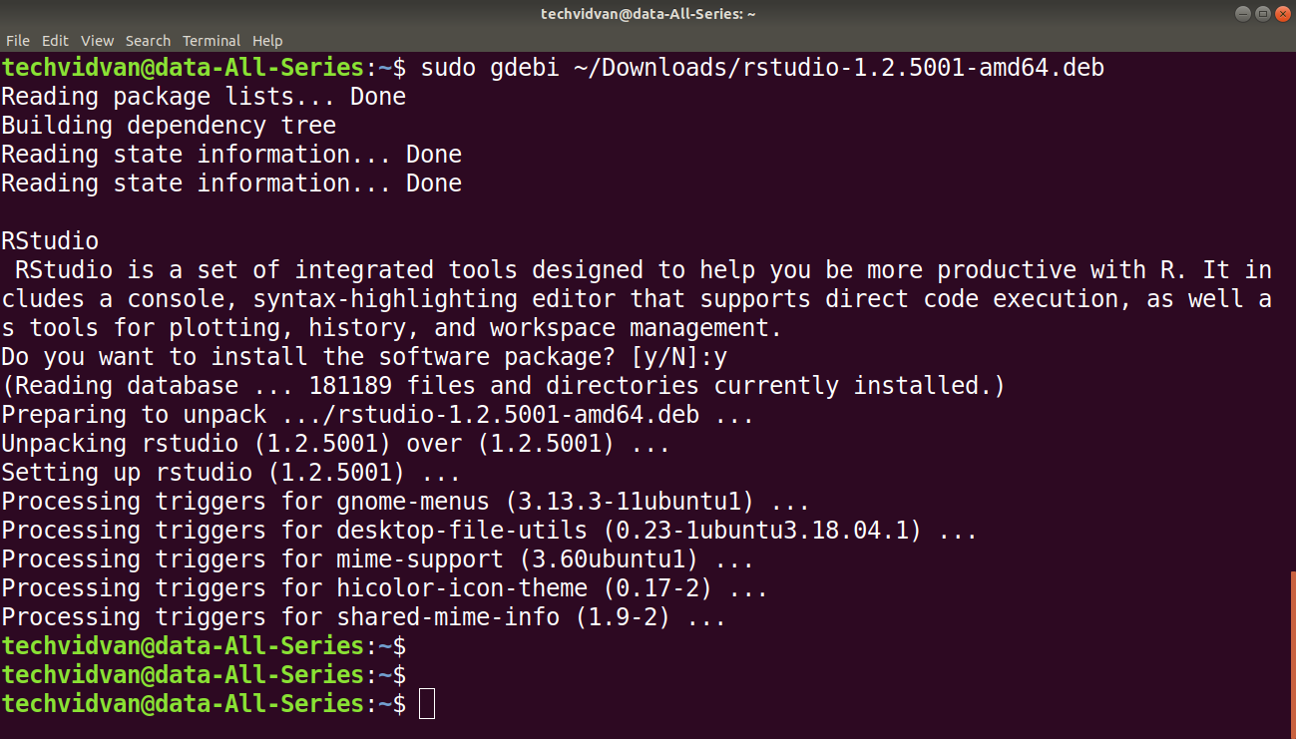

**EXPERIMENT NO**:1(b)  **DATE:**

**Aim:** Basic functionality of R, variable, data types in R.

**Description:**

**Features of R Programming:**

1. Open-source:

R is an open-source software environment(R is freely available).It is free of cost and can be adjusted and adapted according to the user’s and the project’s requirements.You can make improvements and add packages for additional functionalities.

2. Strong Graphical Capabilities:

R can produce static graphics with production quality visualizations and has extended libraries providing interactive graphic capabilities.3. Highly Active Community

### 3. Highly Active Community:

R has an open-source library which is supported by its **growing** number of users.The R environment is continuously growing. This growth is due to its **large user-base**.

1. Distributed Computing:

In distributed computing, tasks are split between multiple processing nodes to reduce processing time and increase efficiency.R has packages like ddR and multiDplyr that enable it to use distributed computing to process large [data sets](https://en.wikipedia.org/wiki/Data_set).

1. Running Code Without a Compiler:

R is an interpreted language which means that it does not need a compiler to make a program from the code. R directly interprets provided code into lower-level calls and pre-compiled code.

1. Cross-platform Support:

R is machine-independent. It supports the cross-platform operation. Therefore, it can be used on many different operating systems.

**variables in R:**

A variable is a memory allocated for the storage of specific data and the name associated with the variable is used to work around this reserved block. The name given to a variable is known as its variable name.

[R Programming Language](https://www.geeksforgeeks.org/introduction-to-r-programming-language/) is a dynamically typed language, i.e. the R Language Variables variables are not declared with a data type rather they take the data type of the R-object assigned to them.

Nomenclature of R Variables:

The following rules need to be kept in mind while naming a variable:

* A valid variable name consists of a combination of alphabets, numbers, dot(.), and underscore(_) characters. Example: var.1_ is valid
* Apart from the dot and underscore operators, no other special character is allowed. Example: var$1 or var#1 both are invalid
* Variables can start with alphabets or dot characters. Example: .var or var is valid
* The variable should not start with numbers or underscore. Example: 2var or _var is invalid.
* If a variable starts with a dot the next thing after the dot cannot be a number. Example: .3var is invalid
* has to be started always with an alphabet.Other special characters like(‘!’, ‘@’, ‘#’, ‘$’) are not allowed in the variable name.

**R supports three ways of variable assignment**:

1. Using equal operator- data is copied from right to left.
2. Using leftward operator- data is copied from right to left.
3. Using rightward operator- data is copied from left to right.

 Syntax:

#using equal to operator

variable_name = value

#using leftward operator

variable_name <- value

#using rightward operator

value -> variable_name

**Data Types:**

Each variable in R has an associated data type. R Programming language has the following basic data types and the following table shows the data type and the values that each data type can take.

1.Numeric Datatype: Decimal values are called numerics in R. It is the default data type for numbers in R.

2.Integer Datatype:R supports integer data types which are the set of all integers. You can create as well as convert a value into an integer type using the as.integer() function. You can also use the capital ‘L’ notation as a suffix to denote that a particular value is of the integer data type.

3.Logical Datatype: R has logical data types that take either a value of true or false. A logical value is often created via a comparison between variables.

## 4.Complex Datatype: R supports complex data types that are set of all the complex numbers. The complex data type is to store numbers with an imaginary component.

5.Character Datatype: R supports character data types where you have all the alphabets and special characters. It stores character values or strings. Strings in R can contain alphabets, numbers, and symbols. The easiest way to denote that a value is of character type in R is to wrap the value inside single or double inverted commas.

* to find the data type of an object you have to use class() function

**Syntax:**  class(object)

**program:**

# R program to illustrate Initialization of variables using equal to operator

var1 = "hello"

print(var1)

var2 < - "hello"# using leftward operator

print(var2)

"hello" -> var3# using rightward operator

print(var3)

# A simple R program to illustrate Numeric data type

x = 5.6# Assign a decimal value to x

print(class(x))# print the class name of variable

print(typeof(x)) # print the type of variable

# A simple R program to illustrate Numeric data type

# Assign a integer value to y

y = 5

print(is.integer(y))# is y an integer?

# A simple R program to illustrate integer data type

 x = as.integer(5)# Create an integer value

print(class(x))

print(typeof(x))

y = 5L# Declare an integer by appending an L suffix.

print(class(y))

print(typeof(y))  
# A simple R program to illustrate logical data type

# Sample values

x = 4

y = 3

# Comparing two values

z = x > y

# print the logical value

print(z)

print(class(z))

print(typeof())

# A simple R program to illustrate complex data type

# Assign a complex value to x

x = 4 + 3i

print(class(x))

print(typeof(x))

#character A simple R program to illustrate character data type

|  |
| --- |
|  |

 # Assign a character value to char

char = "Geeksforgeeks"

print(class(char))

print(typeof(char))

**Output:**

1. "hello"

[1] "hello"

[1] "hello"

[1] "numeric"

[1] "double"

[1] FALSE

#integer

[1] "integer"

[1] "integer"

[1] "integer"

[1] "integer"

#logical

[1] TRUE

[1] "logical"

[1] "logical"

#complex

[1] "complex"

[1] "complex"

#character

[1] "character"

[1] "character"

**EXPERIMENT NO:**2(a)  **DATE:**

**Aim**:Implement R seript to show the usage of various operators available in R language.

**Description:**

Operators are the symbols directing the compiler to perform various kinds of operations between the operands.

R supports majorly four kinds of binary operators between a set of operands.

Types of the operator in R language:

* [Arithmetic Operators](https://www.geeksforgeeks.org/r-operators/#Arithmetic Operators)
* [Logical Operators](https://www.geeksforgeeks.org/r-operators/#Logical Operators)
* [Relational Operators](https://www.geeksforgeeks.org/r-operators/#Relational Operators)
* [Assignment Operators](https://www.geeksforgeeks.org/r-operators/#Assignment Operators)
* [Miscellaneous Operator](https://www.geeksforgeeks.org/r-operators/#Miscellaneous Operator)

## Arithmetic Operators:

Arithmetic operations simulate various math operations, like addition, subtraction, multiplication, division, and modulo using the specified operator between operands, which may be either scalar values, complex numbers, or vectors.

## 1.Addition operator (+): The values at the corresponding positions of both the operands are added.

syntax:a+b

Input : a <- c (1, 0.1)

b <- c (2.33, 4)

print (a+b)

Output : 3.33

4.10

2.Subtraction Operator (-):The second operand values are subtracted from the first.

syntax:a-b

Input : a <- 6

b <- 8.4

print (a-b)

Output : -2.4

3.multiplication Operator (*):  The multiplication of corresponding elements of vectors and Integers are multiplied with the use of ‘*’ operator.

Input : B= matrix(c(4,6i),nrow=1,ncol=2)

C= matrix(c(2,2i ),nrow=1, ncol=2)

print (B*C)

Output : 8+0i

-12+0i

4.Division Operator (/): The first operand is divided by the second operand with the use of ‘/’ operator.

syntax; a/b

Input : a <- 1

b <- 0

print (a/b)

Output : -Inf

5.Power Operator (^):  The first operand is raised to the power of the second operand.

Input : list1 <- c(2, 3)

list2 <- c(2,4)

print(list1^list2)

Output : 4

81

6.Modulo Operator (%%): The remainder of the first operand divided by the second operand is returned.

Input : list1<- c(2, 3)

list2<-c(2,4)

print(list1%%list2)

Output : 0

3

* **Logical Operators**:Logical operations simulate element-wise decision operations, based on the specified operator between the operands, which are then evaluated to either a True or False boolean value. Any non zero integer value is considered as a TRUE value, be it complex or real number.

1.Element-wise Logical AND operator (&):Returns True if both the operands are True.

Input : list1 <- c(TRUE, 0.1)

list2 <- c(0,4+3i)

print(list1 & list2)

Output : FALSE

TRUE

### **Logical OR operator (|):**Returns True if either of the operands are True.

### **Input : list1 <- c(TRUE, 0.1)**

**list2 <- c(0,4+3i)**

**print(list1|list2)**

**Output : TRUE**

### **TRUE**

### **3.NOT operator (!):** A unary operator that negates the status of the elements of the operand.

### **Input : list1 <- c(0,FALSE)**

### **print(!list1)**

### **Output : TRUE**

### **TRUE**

### **4.Logical AND operator (&&):**Returns True if both the first elements of the operands are True.

**Input : list1 <- c(TRUE, 0.1)**

**list2 <- c(0,4+3i)**

**print(list1 && list2)**

**Output : FALSE**

**5.Logical OR operator (||): Returns True if either of the first elements of the operands are True.**

**Input : list1 <- c(TRUE, 0.1)**

**list2 <- c(0,4+3i)**

**print(list1||list2)**

**Output : TRUE**

## ****Relational Operators**:**The relational operators carry out comparison operations between the corresponding elements of the operands.

**Returns a boolean TRUE value if the first operand satisfies the relation compared to the second.**

## ****Assignment Operators:****Assignment operators are used to assign values to various data objects in R. The objects may be integers, vectors, or functions.

**There are two kinds of assignment operators:**

**Left and Right**

1. **Left Assignment (<- or <<- or =): Assigns a value to a vector.**

**Input : vec1 = c("ab", TRUE)**

**print (vec1)**

**Output : "ab" "TRUE"**

1. **Right Assignment (-> or ->>): Assigns value to a vector.**

**Input : c("ab", TRUE) ->> vec1**

**print (vec1)**

**Output : "ab" "TRUE"**

## ****Miscellaneous Operators:****These are the mixed operators that simulate the printing of sequences and assignment of vectors, either left or right-handed.

## 

## **%in% Operator:** Checks if an element belongs to a list and returns a boolean value TRUE if the value is present else FALSE.

### **2.Colon Operator(:):** Prints a list of elements starting with the element before the color to the element after it.

**PROGRAM:**

# R program to illustratethe use of Arithmetic operators

vec1 <- c(0, 2)

vec2 <- c(2, 3)

# Performing operations on Operands

cat ("Addition of vectors :", vec1 + vec2, "\n")

cat ("Subtraction of vectors :", vec1 - vec2, "\n")

cat ("Multiplication of vectors :", vec1 * vec2, "\n")

cat ("Division of vectors :", vec1 / vec2, "\n")

cat ("Modulo of vectors :", vec1 %% vec2, "\n")

cat ("Power operator :", vec1 ^ vec2)

# R program to illustrate the use of Logical operators

vec1 <- c(0,2)

vec2 <- c(TRUE,FALSE)

# Performing operations on Operands

cat ("Element wise AND :", vec1 & vec2, "\n")

cat ("Element wise OR :", vec1 | vec2, "\n")

cat ("Logical AND :", vec1 && vec2, "\n")

cat ("Logical OR :", vec1 || vec2, "\n")

cat ("Negation :", !vec1)

# R program to illustrate the use of Relational operators

vec1 <- c(0, 2)

vec2 <- c(2, 3)

# Performing operations on Operands

cat ("Vector1 less than Vector2 :", vec1 < vec2, "\n")

cat ("Vector1 less than equal to Vector2 :", vec1 <= vec2, "\n")

cat ("Vector1 greater than Vector2 :", vec1 > vec2, "\n")

cat ("Vector1 greater than equal to Vector2 :", vec1 >= vec2, "\n")

cat ("Vector1 not equal to Vector2 :", vec1 != vec2, "\n")

# R program to illustrate the use of Assignment operators

vec1 <- c(2:5)

c(2:5) ->> vec2

vec3 <<- c(2:5)

vec4 = c(2:5)

c(2:5) -> vec5

# Performing operations on Operands

cat ("vector 1 :", vec1, "\n")

cat("vector 2 :", vec2, "\n")

cat ("vector 3 :", vec3, "\n")

cat("vector 4 :", vec4, "\n")

cat("vector 5 :", vec5)

# R program to illustrate the use of Miscellaneous operators

mat <- matrix (1:4, nrow = 1, ncol = 4)

print("Matrix elements using : ")

print(mat)

product = mat %*% t(mat)

print("Product of matrices")

print(product,)

cat ("does 1 exist in prod matrix :", "1" %**in**% product)

**Output:**

Addition of vectors : 2 5

Subtraction of vectors : -2 -1

Multiplication of vectors : 0 6

Division of vectors : 0 0.6666667

Modulo of vectors : 0 2

Power operator : 0 8

Element wise AND : FALSE FALSE

Element wise OR : TRUE TRUE

Logical AND : FALSE

Logical OR : TRUE

Negation : TRUE FALSE

Vector1 less than Vector2 : TRUE TRUE

Vector1 less than equal to Vector2 : TRUE TRUE

Vector1 greater than Vector2 : FALSE FALSE

Vector1 greater than equal to Vector2 : FALSE FALSE

Vector1 not equal to Vector2 : TRUE TRUE

vector 1 : 2 3 4 5

vector 2 : 2 3 4 5

vector 3 : 2 3 4 5

vector 4 : 2 3 4 5

vector 5 : 2 3 4 5

[1] "Matrix elements using : "

[,1] [,2] [,3] [,4]

[1,] 1 2 3 4

[1] "Product of matrices"

[,1]

[1,] 30

does 1 exist in prod matrix : FALSE

**EXPERIMENT NO:**2(B)  **DATE:**

**Aim**:Implement R script to read person's age from keyboard and display whether he is eligible for voting or not.

**Description:**

Else If:

The else if keyword is R's way of saying "if the previous conditions were not true, then try this condition".

syntax:

if( age >= 18)

{

//statement

}

else

{

//statement

}

**PROGRAM:**

{

age <- as.integer(readline(prompt = "Enter your age :"))

if (age >= 18)

{

print(paste("You are valid for voting :", age))

}

else

{

print(paste("You are not valid for voting :", age))

}

}

**OUTPUT:**

Enter your age :48

[1] "You are valid for voting : 48"

**EXPERIMENT NO:**2(c)  **DATE:**

**Aim**:Implement R script to find biggest number between two numbers.

**Description:**

readline(): reads a line from the terminal (in interactive use).

Arguments:

prompt: The string printed when prompting the user for input. Should usually end with a space " ".

**program:**

{

    x <- as.integer(readline(prompt = "Enter first number :"))

    y <- as.integer(readline(prompt = "Enter second number :"))

    z <- as.integer(readline(prompt = "Enter third number :"))

if (x > y) {

      if (x > z)

        print(paste("Greatest is :", x))

      else

        print(paste("Greatest is :", z))

    } else  {

      if (y > z)

        print(paste("Greatest is :", y))

      else{

        print(paste("Greatest is :", z))

      }

    }

}

**output:**

Enter first number :3

Enter second number :2

Enter third number :55

1. "Greatest is : 55"

**EXPERIMENT NO:**2(d)  **DATE:**

**Aim:**Implement R script to check the given year is leap year or not.

**Description:**

A leap year is exactly divisible by 4 except for century years (years ending with 00). The century year is a leap year only if it is perfectly divisible by 400.

if...else:

The if-else statement helps to check the condition based on the condition the expression is performed. The syntax of if-else statement is like,

if (condition1) {

expr1

} else if (condition2) {

expr2

} else if (condition3) {

expr3

} else {

expr4

}

Modulo Operator (%%):

The remainder of the first operand divided by the second operand is returned.

Input : list1<- c(2, 3)

list2<-c(2,4)

print(list1%%list2)

Output : 0 3

**program:**

# Program to check if the input year is a leap year or not

year = as.integer(readline(prompt="Enter a year: "))

if((year %% 4) == 0) {

if((year %% 100) == 0) {

if((year %% 400) == 0) {

print(paste(year,"is a leap year"))

} else {

print(paste(year,"is not a leap year"))

}

} else {

print(paste(year,"is a leap year"))

}

} else {

print(paste(year,"is not a leap year"))

}

**output:**

Enter a year: 1900

[1] "1900 is not a leap year"

**Week 3:**

**EXPERIMENT NO:**3(A)  **DATA:**

**Aim:** Implement R Script to create a list.

**Description:**

 List is a data structure having components of mixed data types.

A [vector](https://www.datamentor.io/r-programming/vector) having all elements of the same type is called atomic vector but a vector having elements of different type is called list.

* List can be created using the list() function.

x <- list("a" = 2.5, "b" = TRUE, "c" = 1:3)

* The list elements can be given names and they can be accessed using these names.

**PROGRAM:**

# Create a list containing a vector, a matrix and a list.

list_data <- list(c("Jan","Feb","Mar"), matrix(c(3,9,5,1,-2,8), nrow = 2),

list("green",12.3))

# Give names to the elements in the list.

names(list_data) <- c("1st Quarter", "A_Matrix", "A Inner list")

# Show the list.print(list_data)

**OUTPUT:**

$`1st_Quarter`

[1] "Jan" "Feb" "Mar"

$A_Matrix

[,1] [,2] [,3]

[1,] 3 5 -2

[2,] 9 1 8

$A_Inner_list

$A_Inner_list[[1]]

[1] "green"

$A_Inner_list[[2]]

[1] 12.3

**EXPERIMENT NO:**3(b)  **DATA:**

**Aim:**Implement R Seript to access elements in the list.

**Description**:Elements of the list can be accessed by the index of the element in the list. In case of named lists it can also be accessed using the names

**Program:**

# Create a list containing a vector, a matrix and a list.

list_data <- list(c("Jan","Feb","Mar"), matrix(c(3,9,5,1,-2,8), nrow = 2),

list("green",12.3))

# Give names to the elements in the list.

names(list_data) <- c("1st Quarter", "A_Matrix", "A Inner list")

# Access the first element of the list.

print(list_data[1])

# Access the thrid element. As it is also a list, all its elements will be printed.

print(list_data[3])

# Access the list element using the name of the element

.print(list_data$A_Matrix)

**Output:**

$`1st_Quarter`

[1] "Jan" "Feb" "Mar"

$A_Inner_list

$A_Inner_list[[1]]

[1] "green"

$A_Inner_list[[2]]

[1] 12.3

[,1] [,2] [,3]

[1,] 3 5 -2

[2,] 9 1 8

**EXPERIMENT NO:**3(c)  **DATA:**

**Aim:** Implement R Script to merge two or more lists.

**Description:**

Merging Lists:

You can merge many lists into one list by placing all the lists inside one list() function.

Syntax:  
merge(df1, df2, by.df1, by.df2, all.df1, all.df2, sort = TRUE)

Parameters:  
df1: one dataframe  
df2: another dataframe  
by.df1, by.df2: The names of the columns that are common to both df1 and df2.  
all, all.df1, all.df2: Logical values that actually specify the type of merging happens.

**program:**

df1 = data.frame(StudentId = c(101:106),

                 Product = c("Hindi", "English",

                             "Maths", "Science",

                             "Political Science",

                             "Physics"))

df1

**output:**

StudentId Product

1 101 Hindi

2 102 English

3 103 Maths

4 104 Science

5 105 Political Science

6 106 Physics

**EXPERIMENT NO:**3(d)  **date:**

**Aim:** Implement R Script to perform matrix operation.

**DESCRIPTION:**

Matrices in R are a bunch of values, either real or complex numbers, arranged in a group of fixed number of rows and columns.

**Operations on Matrices**

There are four basic operations i.e. DMAS (Division, Multiplication, Addition, Subtraction) that can be done with matrices. Both the matrices involved in the operation should have the same number of rows and columns.

**Program:**

#Adding Both Matrices

myMatrixCAfterAdding <- myMatrixA + myMatrixB

myMatrixCAfterAdding

#Subtracting Matrix

myMatrixCAfterSubtraction <- myMatrixA - myMatrixB

myMatrixCAfterSubtraction

# R program for matrix multiplication using '*' operator

# Creating 1st Matrix

B **=** matrix(c(1, 2 **+** 3i, 5.4), nrow **=** 1, ncol **=** 3)

# Creating 2nd Matrix

C **=** matrix(c(2, 1i, 0.1), nrow **=** 1, ncol **=** 3)

# Printing the resultant matrix

print (B **\*** C)

# R program for matrix divisionusing '/' operator

# Creating 1st Matrix

B **=** matrix(c(4, 6i, **-**1), nrow **=** 1, ncol **=** 3)

# Creating 2nd Matrix

C **=** matrix(c(2, 2i, 0), nrow **=** 1, ncol **=** 3)

# Printing the resultant matrix

print (B **/** C)

**Output**

> myMatrixCAfterAdding

[,1] [,2] [,3]

[1,] 2 8 14

[2,] 4 10 16

[3,] 6 12 18

> myMatrixCAfterSubtraction

[,1] [,2] [,3]

[1,] 0 0 0

[2,] 0 0 0

[3,] 0 0 0

[,1] [,2] [,3]

[1,] 2+0i -3+2i 0.54+0i

[,1] [,2] [,3]

[1,] 2+0i 3+0i -Inf+NaNi

**EXPERIMENT NO:**4(a)  **date:**

**Aim**: Implement R script to perform various operations on vectors.

**DESCRIPTION:**

 Vectors contain a sequence of homogeneous types of data.  Vectors are nothing but arrays as defined in other languages.  Even a single object created is also stored in the form of a vector.  There are various operations that can be performed on vectors in R.

**Creating a vector**

Vectors can be created in many ways as shown in the following example. The most usual is the use of ‘c’ function to combine different elements together.

**Accessing vector elements**

#### The most basic is using the ‘[]’, subscript operator.

#### Modifying a vector:Vectors can be modified using different indexing variations

**Deleting a vector:**

Vectors can be deleted by reassigning them as NULL. To delete a vector we use the NULL operator.   
 **Arithmetic operations:**We can perform arithmetic operations between 2 vectors. These operations are performed element-wise and hence the length of both the vectors should be the same.

**Sorting of Vectors:**For sorting we use the **sort()** function which sorts the vector in ascending order by default.   
 **PROGRAM:**

# Use of 'c' functionto combine the values as a vector. by default the type will be double

X <**-** c(1, 4, 5, 2, 6, 7)

print('using c function')

print(X)

# using the seq() function to generate a sequence of continuous values with different step-size and length.

#length.out defines the length of vector.

Y <**-** seq(1, 10, length.out **=** 5)

print('using seq() function')

print(Y)

# using ':' operator to create a vector of continuous values.

Z <**-** 5:10

print('using colon')

**print**(Y)

|  |  |
| --- | --- |
| # Accessing elements using the position number.  X <**-** c(2, 5, 8, 1, 2)  print('using Subscript operator')  print(X[2])  # Accessing specific values by passing a vector inside another vector.  Y <**-** c(4, 5, 2, 1, 7)  print('using c function')  **print**(Y[c(4, 1)])    # Logical indexing  Z <**-** c(5, 2, 1, 4, 4, 3)  print('Logical indexing')  print(Z[Z>3])  # Creating a vector  X <**-** c(2, 5, 1, 7, 8, 2)  # modify a specific element  X[3] <**-** 11  print('Using subscript operator')  print(X)  # Modify using different logics.  X[X>9] <**-** 0  **print**('Logical indexing')  print(X)  # Modify by specifying the position or elements.  X <**-** X[c(5, 2, 1)]  print('using c function')  print(X)  # Creating a vector  X <**-** c(5, 2, 1, 6)  # Deleting a vector  X <**-** NULL  print('Deleted vector')  print(X)   |  | | --- | | # Creating Vectors  X <**-** c(5, 2, 5, 1, 51, 2)  Y <**-** c(7, 9, 1, 5, 2, 1)  # Addition  Z <**-** X **+** Y  print('Addition')  **print**(Z)  # Subtraction  S <**-** X **-** Y  **print**('Subtraction')  **print**(S)  # Multiplication  M <**-** X **\*** Y  **print**('Multiplication')  print(M)  # Division  D <**-** X **/** Y  print('Division')  print(D) |   # Creating a Vector  X <**-** c(5, 2, 5, 1, 51, 2)  # Sort in ascending order  A <**-** sort(X)  print('sorting done in ascending order')  print(A)  # sort in descending order.  B <**-** sort(X, decreasing **=** TRUE)  print('sorting done in descending order')  print(B) |

**OUTPUT:**

using c function 1 4 5 2 6 7

using seq function 1.00 3.25 5.50 7.75 10.00

using colon 5 6 7 8 9 10

using Subscript operator 5

using c function 1 4

Logical indexing 5 4 4

Using subscript operator 2 5 11 7 8 2

Logical indexing 2 5 0 7 8 2

using c function 8 5 2

Deleted vector NULL

Addition 12 11 6 6 53 3

Subtraction -2 -7 4 -4 49 1

Multiplication 35 18 5 5 102 2

Division 0.7142857 0.2222222 5.0000000 0.2000000 25.5000000 2.0000000

sorting done in ascending order 1 2 2 5 5 51

sorting done in descending order 51 5 5 2 2 1

**EXPERIMENT NO:**4(b)  **date:**

**Aim**: Implement R script to find the sum and average of given numbers using arrays.

**DESCRIPTION:**

* Arrays are the R data objects which can store data in more than two dimensions. For
* An array is created using the **array()** function. It takes vectors as input and uses the values in the **dim** parameter to create an array.

The sum() is a built-in R function that calculates the sum of a numeric input vector. It accepts a numeric vector as an argument and returns the sum of the vector elements. To calculate the sum of vectors in R, use the sum() function.

**Syntax:**

sum(x, na.rm = FALSE, …)

**PROGRAM:**

rv <- c(11, 19, 21, 18, 46)

#calculates the sum of the values

sum(rv)

**OUTPUT:**

**EXPERIMENT NO:**4(c) **DATE:**

**Aim:** Implement R script to display elements of list in reverse order.

**DESCRIPTION:** Lists are the R objects which contain elements of different types like − numbers, strings, vectors and another list inside it. A list can also contain a matrix or a function as its elements. List is created using **list()** function.

To reverse the elements of a list we use the rev() function and pass given list as argument to it.

Rev() -function returns a new list with the contents of given list in reverse order.

syntax:

rev(x)

**PROGRAM:**

# create vector with names

vec = c("sravan", "mohan", "sudheer", "radha", "vani", "mohan")

print("Original vector-1:")

print(vec)

rv = rev(vec)

print("The said vector in reverse order:")

print(rv)

**OUTPUT:**

[1] “Original vector-1:”

[1] “sravan”  “mohan”   “sudheer” “radha”   “vani”    “mohan”

[1] “The said vector in reverse order:”

[1] “mohan”   “vani”    “radha”   “sudheer” “mohan”   “sravan”

**EXPERIMENT NO:**4(d) **DATE:**

**Aim:** Implement R to find the minimum and maximum elements in the array.

**DESCRIPTION:**

* The **R max function** returns the **maximum value** of a vector or column.  
  The **R min function** returns the **minimum value** of a vector or column.
* A function called range() is also available which returns the minimum and maximum in a two element vector.

Syntax:

max(x)

min(x)

range(x)

**PROGRAM:**

w<-( 5 , 8, 3 , 9 , 2, 7, 4, 6 ,10)

min(w)

max(w)

range(w)

**OUTPUT:**

[1] 2

[1] 10

[1] 2 10

**Week 5:**

**EXPERIMENT NO:**5(b) **DATE:**

**AIM:** Implement R Script to extract the data from data frames.

**DESCRIPTION:** Data Frames are generic data objects of R which are used to store the tabular data. Data frames are considered to be the most popular data objects in R programming because it is more comfortable to analyze the data in the tabular form. Data frames can also be taught as matrices where each column of a matrix can be of the different data types. Data Frame are made up of three principal components, the data, rows, and columns.

**Creating a data frame using Vectors:**To create a data frame we use the **data.frame()** function in R. To create a data frame use**data.frame()** command and then pass each of the vectors you have created as arguments to the function.

* The dimension and head of the data frame are extracted using dim() and head() functions.

Syntax:  
dim(df)  
head(df)

* Rows can be extracted by their locations as :

# Extract the nth row

df[n,]

# Extract the first n rows

df[1:n,]

### or ###

df[c(1,2,…..,n),]

* Columns can be extracted by their location as:

# Extract the nth column

df[,n]

## Extract the first n columns

df[,1:n]

* **Extract rows/columns by index or conditions:**

# R

## Extract 1999-2000 season.

df["1999-00",]

## Extract 1999-2000 and 2001-2002 seasons.

df[c("1999-00","2000-01"),]

df[df$varname, condition]

**PROGRAM &OUTPUT:**

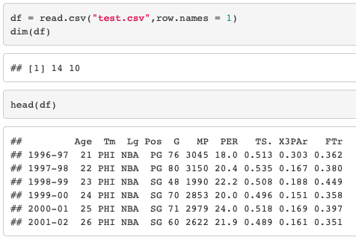

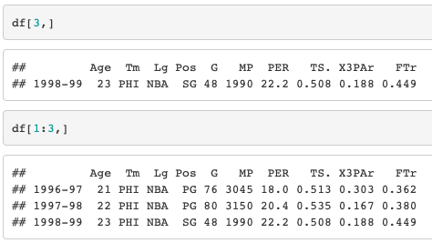

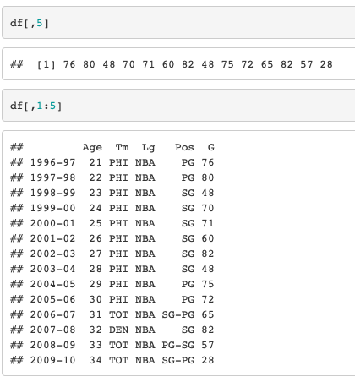

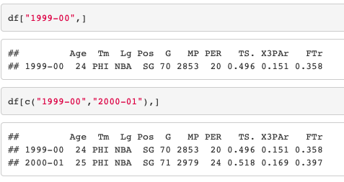

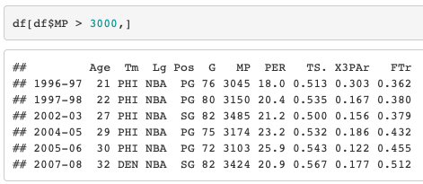

**EXPERIMENT NO:**5(C) **DATE:**

**AIM:** Write R script to display file contents.

**DESCRIPTION:**

 The two most common operations that can be performed on a file are:

* Importing/Reading Files in R
* Exporting/Writing Files in R

**File reading in R**

One of the important formats to store a file is in a text file. R provides various methods that one can read data from a text file.

* **read.delim()**: This method is used for reading “tab-separated value” files (“.txt”). By default, point (“.”) is used as decimal points.

Syntax: read.delim(file, header = TRUE, sep = “\t”, dec = “.”, …)

Parameters:

file: the path to the file containing the data to be read into R.

header: a logical value. If TRUE, read.delim() assumes that your file has a header row, so row 1 is the name of each column. If that’s not the case, you can add the argument header = FALSE.

sep: the field separator character. “\t” is used for a tab-delimited file.

dec: the character used in the file for decimal points

* **read.delim2()**: This method is used for reading “tab-separated value” files (“.txt”). By default, point (“,”) is used as decimal points.

Syntax: read.delim2(file, header = TRUE, sep = “\t”, dec = “,”, …)

Parameters:

file: the path to the file containing the data to be read into R.

header: a logical value. If TRUE, read.delim2() assumes that your file has a header row, so row 1 is the name of each column. If that’s not the case, you can add the argument header = FALSE.

sep: the field separator character. “\t” is used for a tab-delimited file.

dec: the character used in the file for decimal points.

* **file.choose()**: In R it’s also possible to choose a file interactively using the function **file.choose()**, and if you’re a beginner in R programming then this method is very useful for you.

**Reading one line at a time**:

**read_lines()**: This method is used for the reading line of your own choice whether it’s one or two or ten lines at a time. To use this method we have to import **reader** package.

**Syntax:**read_lines(file, skip = 0, n_max = -1L)

**Parameters:**

file: file path

skip: Number of lines to skip before reading data

n_max: Numbers of lines to read. If n is -1, all lines in the file will be read.

**Reading a file in a table format:**

Another popular format to store a file is in a tabular format. R provides various methods that one can read data from a tabular formatted data file.

**read.table()**: read.table() is a general function that can be used to read a file in table format. The data will be imported as a data frame.

**Syntax:**read.table(file, header = FALSE, sep = “”, dec = “.”)

**Parameters:**

file: the path to the file containing the data to be imported into R.

header: logical value. If TRUE, read.table() assumes that your file has a header row, so row 1 is the name of each column. If that’s not the case, you can add the argument header = FALSE.

sep: the field separator character

dec: the character used in the file for decimal points.

**PROGRAM:**

myData = read.delim("geeksforgeeks.txt", header = **FALSE**)

print(myData)

myData = read.delim2("geeksforgeeks.txt", header = **FALSE**)

print(myData)

myFile = read.delim(file.choose(), header = **FALSE**)

print(myFile)

# R program to read one line at a time .Import the readr library

library(readr)

# read_lines() to read one line at a time

myData = read_lines("geeksforgeeks.txt", n_max = 1)

print(myData)

# read_lines() to read two line at a time

myData = read_lines("geeksforgeeks.txt", n_max = 2)

print(myData)

myData = read.table("basic.csv")

print(myData)

**output:**

This is the output of the read.delim() function guys.

This is the output of the read.delim2() function guys.

This is the output of the file.choose() function guys.

“This is the output of the read lines one at a time guys.”

“Hey this is the output of the read lines two at a time as per the condition.”

“do you understand? this is the next line .”

1 Name,Age,Qualification,Address

2 Amiya,18,MCA,BBS

3 Niru,23,Msc,BLS

4 Debi,23,BCA,SBP

5 Biku,56,ISC,JJP

**EXPERIMENT NO:**5(d) **DATE:**

**AIM:** Write R script to copy file contents from one file to another.

**DESCRIPTION:**

R provides many built-in functions that we can use to perform the file operations. Copy a file from one folder to another programmatically is one of the most important operations, and R provides a built-in function for that.

To copy a file in R, use the file.copy() method. The file.copy() function works in the same way as a file.append() function but with the arguments in the natural order for copying.

Syntax:

file.copy(from, to, overwrite = recursive, recursive = FALSE,copy.mode = TRUE,

copy.date = FALSE)

parameters:

Copying to existing destination files is skipped unless overwrite = **TRUE**.

**from, to**: They are character vectors containing file names or paths.

**overwrite**: It is logical; should existing destination files be overwritten?

**recursive**: It is logical. If to is a directory, should directories in from being copied (and their contents)?

**copy.mode:** It is logical: should file permission bits be copied where possible?

**copy.date:** It is logical: should file dates be preserved where possible?

**PROGRAM:**

dir.create("newdir")

newDirPath <- "newdir"

files <- c("a.txt")

file.create(files)

newFilePath <- "a.txt"

file.copy(newFilePath, newDirPath)

**OUTPUT:**

[1] TRUE

[1] TRUE

**WEEK 6:**

**EXPERIMENT NO:**6(a) **DATE:**

**AIM:** Write an R script to find basic descriptive statistics using summary, str, quartile function on mtcars & cars datasets.

**DESCRIPTION:**

Descriptive statistics is the branch of statistics that focuses on **describing** and gaining more insight into the data in its present state. It makes the data easier to understand and also gives us knowledge about the data which is necessary to perform further analysis. Average measures like mean, median, mode, etc. are a good example of descriptive statistics.

R programming language provides us with lots of simple yet effective functions to perform descriptive statistics and gain more knowledge about our data. Summarizing the data, calculating average measures, finding out cumulative measures, summarizing rows/columns of data structures, etc. everything is possible with trivial commands. Let’s start simple with the summarizing functions **str()** and **summary()**.

* The **str()** function takes a single object as an argument and compactly shows us the **structure** of the input object. It shows us details like length, data type, names and other specifics about the components of the object.
* The summary() function also takes a single object as an argument. It then returns the averages measures like mean, median, minimum, maximum, 1st quantile, 3rd quantile, etc. for each component or variable in the object.
* the quantile() function: As the median, the first and third quartiles can be computed thanks to the quantile() function. quantile can also be computed with the quantile() function.

Syntax: quantile(dat$Sepal.Length, quartilenumner/100)

**PROGRAM:**

str(mtcars)

str(cars)

summary(mtcars)

summary(cars)

quantile(mtcars$dist,0.45)

quantile(cars$speed,0.94)

**OUTPUT:**

#str(mtcars)

'data.frame': 32 obs. of 11 variables:

$ mpg : num 21 21 22.8 21.4 18.7 18.1 14.3 24.4 22.8 19.2 ...

$ cyl : num 6 6 4 6 8 6 8 4 4 6 ...

$ disp: num 160 160 108 258 360 ...

$ hp : num 110 110 93 110 175 105 245 62 95 123 ...

$ drat: num 3.9 3.9 3.85 3.08 3.15 2.76 3.21 3.69 3.92 3.92 ...

$ wt : num 2.62 2.88 2.32 3.21 3.44 ...

$ qsec: num 16.5 17 18.6 19.4 17 ...

$ vs : num 0 0 1 1 0 1 0 1 1 1 ...

$ am : num 1 1 1 0 0 0 0 0 0 0 ...

$ gear: num 4 4 4 3 3 3 3 4 4 4 ...

$ carb: num 4 4 1 1 2 1 4 2 2 4 ...

#str(cars)

'data.frame': 50 obs. of 2 variables:

$ speed: num 4 4 7 7 8 9 10 10 10 11 ...

$ dist : num 2 10 4 22 16 10 18 26 34 17 ...

#summary(mtcars)

mpg cyl disp hp

Min. :10.40 Min. :4.000 Min. : 71.1 Min. : 52.0

1st Qu.:15.43 1st Qu.:4.000 1st Qu.:120.8 1st Qu.: 96.5

Median :19.20 Median :6.000 Median :196.3 Median :123.0

Mean :20.09 Mean :6.188 Mean :230.7 Mean :146.7

3rd Qu.:22.80 3rd Qu.:8.000 3rd Qu.:326.0 3rd Qu.:180.0

Max. :33.90 Max. :8.000 Max. :472.0 Max. :335.0

drat wt qsec vs

Min. :2.760 Min. :1.513 Min. :14.50 Min. :0.0000

1st Qu.:3.080 1st Qu.:2.581 1st Qu.:16.89 1st Qu.:0.0000

Median :3.695 Median :3.325 Median :17.71 Median :0.0000

Mean :3.597 Mean :3.217 Mean :17.85 Mean :0.4375

3rd Qu.:3.920 3rd Qu.:3.610 3rd Qu.:18.90 3rd Qu.:1.0000

Max. :4.930 Max. :5.424 Max. :22.90 Max. :1.0000

am gear carb

Min. :0.0000 Min. :3.000 Min. :1.000

1st Qu.:0.0000 1st Qu.:3.000 1st Qu.:2.000

Median :0.0000 Median :4.000 Median :2.000

Mean :0.4062 Mean :3.688 Mean :2.812

3rd Qu.:1.0000 3rd Qu.:4.000 3rd Qu.:4.000

Max. :1.0000 Max. :5.000 Max. :8.000

#quantile(mtcars)

45%

167.22

#quantile(cars)

94%

24

**WEEK 6:**

**EXPERIMENT NO:**6(b) **DATE:**

**AIM:** Write an R script to find subset of dataset by using subset (), aggregate () functions on iris dataset.

**DESCRIPTION:**

Aggregate() Function in R Splits the data into subsets, computes summary statistics for each subsets and returns the result in a group by form.

 Aggregate() function is useful in performing all the aggregate operations like sum,count,mean, minimum and Maximum.

Syntax: aggregate(x, by, FUN, …, simplify = TRUE, drop = TRUE)

**PROGRAM:**

agg_mean = aggregate(iris[,1:4],by=list(iris$Species),FUN=mean, na.rm=TRUE)

print(agg_mean)

agg_sum = aggregate(iris[,1:4],by=list(iris$Species),FUN=sum, na.rm=TRUE)

agg_sum

agg_count = aggregate(iris[,1:4],by=list(iris$Species),FUN=length)

agg_count

agg_max = aggregate(iris[,1:4],by=list(iris$Species),FUN=max, na.rm=**TRUE**)

agg_max

agg_min = aggregate(iris[,1:4],by=list(iris$Species),FUN=min, na.rm=**TRUE**)

agg_min

subset(iris, Species == "setosa")[1:5,]

**OUTPUT:**

Group.1 Sepal.Length Sepal.Width Petal.Length Petal.Width

1 setosa 5.006 3.428 1.462 0.246

2 versicolor 5.936 2.770 4.260 1.326

3 virginica 6.588 2.974 5.552 2.026

Group.1 Sepal.Length Sepal.Width Petal.Length Petal.Width

1 setosa 250.3 171.4 73.1 12.3

2 versicolor 296.8 138.5 213.0 66.3

3 virginica 329.4 148.7 277.6 101.3

Group.1 Sepal.Length Sepal.Width Petal.Length Petal.Width

1 setosa 50 50 50 50

2 versicolor 50 50 50 50

3 virginica 50 50 50 50

Group.1 Sepal.Length Sepal.Width Petal.Length Petal.Width

1 setosa 5.8 4.4 1.9 0.6

2 versicolor 7.0 3.4 5.1 1.8

3 virginica 7.9 3.8 6.9 2.5

Group.1 Sepal.Length Sepal.Width Petal.Length Petal.Width

1 setosa 4.3 2.3 1.0 0.1

2 versicolor 4.9 2.0 3.0 1.0

3 virginica 4.9 2.2 4.5 1.4

**Sepal.Length Sepal.Width Petal.Length Petal.Width Species**

1 5.1 3.5 1.4 0.2 setosa

2 4.9 3.0 1.4 0.2 setosa

3 4.7 3.2 1.3 0.2 setosa

4 4.6 3.1 1.5 0.2 setosa

5 5.0 3.6 1.4 0.2 setosa

**Week 7:**

**EXPERIMENT NO:**7(a) **DATE:**

**AIM:** Reading different types of data sets (.txt, .csv) from Web or disk and writing in file in specific disk location.

**DESCRIPTION:** Usually we will be using data already in a file that we need to read into R in order to work on it. R can read data from a variety of file formats—for example, files created as text, or in Excel, SPSS or Stata. We will mainly be reading files in text format .txt or .csv (comma-separated, usually created in Excel).

To read an entire data frame directly, the external file will normally have a special form

* The first line of the file should have a *name* for each variable in the data frame.
* Each additional line of the file has as its first item a *row label* and the values for each variable.

Read CSV Files into R: If your separates the values with a , or ;, you usually are working with a .csv file.

write.csv() uses “.” for the decimal point and a comma (“,”) for the separator.

write.csv2() uses a comma (“,”) for the decimal point and a semicolon (“;”) for the separator.

syntax :

write.csv(my_data, file = "my_data.csv")

write.csv2(my_data, file = "my_data.csv")

**PROGRAM:**

df <- read.table("https://s3.amazonaws.com/assets.datacamp.com/blog_assets/test.txt", header = FALSE)

print(df)

df <- read.table("https://s3.amazonaws.com/assets.datacamp.com/blog_assets/test.csv", header = FALSE, sep = ",")

df <- read.csv(“<https://s3.amazonaws.com/assets.datacamp.com/blog_assets/test.csv>”,header = FALSE)

df <- read.csv2("https://s3.amazonaws.com/assets.datacamp.com/blog_assets/test.csv", header= FALSE)

df

data("mtcars") # Writing mtcars data

write.table(mtcars, file = "mtcars.txt", sep = "\t",row.names = TRUE, col.names = NA)

write.table(mtcars, file = "mtcars.txt", sep = "\t",row.names = FALSE)

**OUTPUT:**

V1 V2 V3

1 1 6 a

2 2 7 b

3 3 8 c

4 4 9 d

5 5 10 e

V1

1 Col1,Col2,Col3

2 1,2,3

3 4,5,6

4 7,8,9

5 a,b,c

[execution complete with exit code 0]

[execution complete with exit code 0]

**EXPERIMENT NO:**7(b) **DATA:**

**AIM:**Reading Excel data sheet in R.

**DESCRIPTION:** In this article, we will be discussing two different techniques to read or import an excel file in R.

**Approach**

* Import module
* Pass path of the file to required function
* Read file
* Display content.

read_excel(): function is basically used to import/read an excel file and it can only be accessed after importing of the readxl library in R language..

Syntax: read_excel(path)

read.xlsx(): function is imported from the xlsx library of R language and used to read/import an excel file in R language.

Syntax: read.xlsx(path)

**PROGRAM:**

library(readxl)

Data_gfg <- read_excel("Data_gfg.xlsx")

Data_gfg

install.packages("xlsx")

Data_gfg <-read.xlsx('Data_gfg.xlsx')

Data_gfg

**Output:**

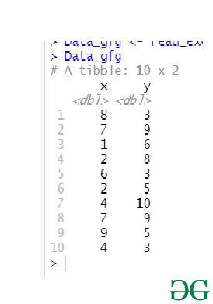 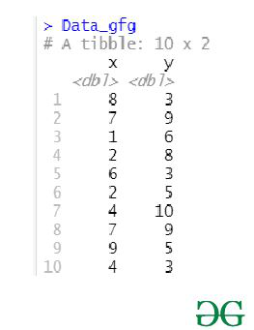

**EXPERIMENT NO:**7(c) **DATA:**

**AIM:** Reading XML data sheet in R.

**DESCRIPTION:**

XML which stands for Extensible Markup Language is made up of markup tags, wherein each tag illustrates the information carried by the particular attribute in the XML file. We can work with the XML files using the XML package provided by R. The package has to be explicitly installed using the following command:

install.packages("XML")

#### Reading XML File:

The XML file can be read after installing the package and then parsing it with **xmlparse()** function.

**PROGRAM:**

library("XML")

library("methods")

# the contents of sample.xml are parsed

data <**-** xmlParse(file **=** "sample.xml")

print(data)

**OUTPUT:**

1

Alia

620

IT

2

Brijesh

440

Commerce

3

Yash

600

Humanities

4

Mallika

660

IT

5

Zayn

560

IT

**Week 8:**

**EXPERIMENT NO:**8(a) **DATE:**

**AIM:** Implement R Script to create a Pie chart, Bar Chart, scatter plot and Histogram (Introduction to ggplot2 graphics)

**DESCRIPTION:**

**Types of Graphs in R:**A variety of graphs is available in R, and the use is solely governed by the context. However, exploratory analysis requires the use of certain graphs in R, which must be used for analyzing data.

**1. Histogram**

A histogram is a graphical tool that works on a single variable. Numerous variable values are grouped into bins, and a number of values termed as the frequency are calculated. This calculation is then used to plot frequency bars in the respective beans. The height of a bar is represented by frequency.

In R, we can employ the hist() function as shown below, to generate the histogram.

**2. Scatterplot:**This plot is a simple chart type, but a very crucial one having tremendous significance. The chart gives the idea about a correlation amongst variables and is a handy tool in an exploratory analysis.

3**.bar chart**:A bar chart represents data in rectangular bars with length of the bar proportional to the value of the variable. R uses the function **barplot()** to create bar charts. R can draw both vertical and Horizontal bars in the bar chart. In bar chart each of the bars can be given different colors.

Syntax:barplot(H,xlab,ylab,main, names.arg,col)

**4.pie chart:**  A pie-chart is a representation of values as slices of a circle with different colors. The slices are labeled and the numbers corresponding to each slice is also represented in the chart.

In R the pie chart is created using the **pie()** function which takes positive numbers as a vector input.

Syntax:pie(x, labels, radius, main, col, clockwise)

**ggplot2 package in R Programming Language:** also termed as **Grammar of Graphics** is a free, open-source, and easy-to-use visualization package widely used in [R](https://www.geeksforgeeks.org/introduction-to-r-programming-language/). It is the most powerful visualization package.

**Building Blocks of layers with the grammar of graphics:**

* **Data:**The element is the data set itself
* **Aesthetics:**The data is to map onto the Aesthetics attributes such as x-axis, y-axis, color, fill, size, labels, alpha, shape, line width, line type
* **Geometrics:**How our data being displayed using point, line, histogram, bar, boxplot
* **Facets:**It displays the subset of the data using Columns and rows
* **Statistics:**Binning, smoothing, descriptive, intermediate
* **Coordinates:**the space between data and display using Cartesian, fixed, polar, limits
* **Themes:**Non-data link

**PROGRAM:**

hist(trees$Height, breaks = 10, col = "orange", main = "Histogram of Tree heights", xlab = "Height Bin")

attach(trees)  
plot(Girth, Height, main = "Scatterplot of Girth vs Height", xlab = "Tree Girth", ylab = "Tree Height")  
abline(lm(Height ~ Girth), col = "blue", lwd = 2)

# Create the data for the chart

H <- c(7,12,28,3,41)

M <- c("Mar","Apr","May","Jun","Jul")

png(file = "barchart_months_revenue.png")# Give the chart file a name

barplot(H,names.arg=M,xlab="Month",ylab="Revenue",col="blue",

main="Revenue chart",border="red")# Plot the bar chart

dev.off()# Save the file

# Create data for the pie chart

x <- c(21, 62, 10,53)

labels <- c("London","New York","Singapore","Mumbai")

piepercent<- round(100*x/sum(x), 1)

# Give the chart file a name.

png(file = "city_percentage_legends.jpg")

# Plot the chart.

pie(x, labels = piepercent, main = "City pie chart",col = rainbow(length(x)))

legend("topright", c("London","New York","Singapore","Mumbai"), cex = 0.8,

fill = rainbow(length(x)))

# Save the file.

Dev.off()

**OUTP**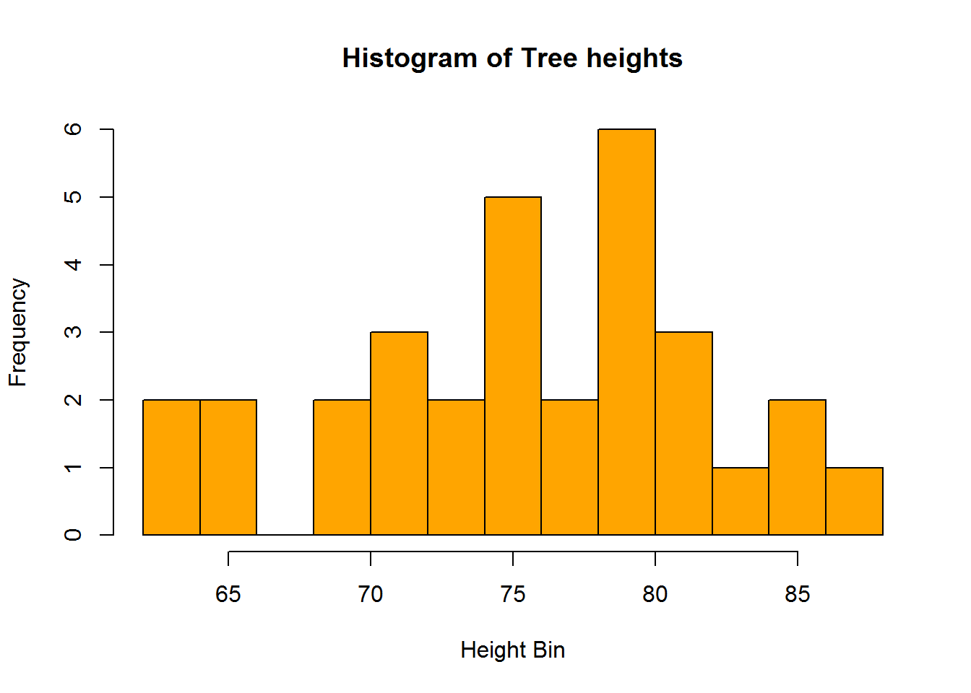

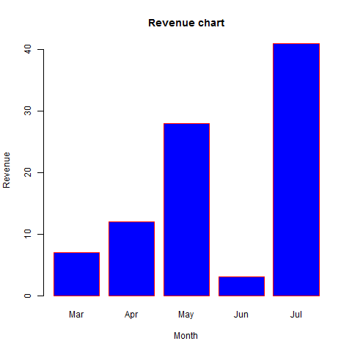

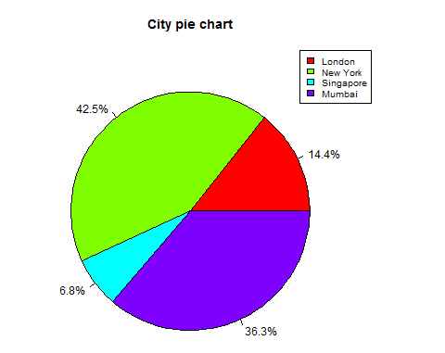

**EXPERIMENT NO:**8(b) **DATE:**

**AIM:** Implement R Script to perform mean, median, mode, range, summary, variance, standard deviation operations.

**DESCRIPTION:**

**Mean:** Calculate sum of all the values and divide it with the total number of values in the data set.

**Median:**The middle value of the data set**.**

**Mode:** The most occurring number in the data set. For calculating mode, there is no default function in R.

**Variance:** How far a set of data values are spread out from their mean.

**Standard Deviation:** A measure that is used to quantify the amount of variation or dispersion of a set of data values.

**range()**: function is used to find the lowest and highest value of the vector .range() function of a vector with NA values  by using na.rm = FALSE.Highest and lowest value of the column in dataframe is also accomplished using range() function.

**summary in R:**The summary is a built-in R function used to produce result summaries of various model fitting functions. The summary() function implores specific methods that depend on the class of the first argument.

**PROGRAM:**

x<-c(1,2,3,4,5,1,2,3,1,2,4,5,2,3,1,1,2,3,5,6)

mean.result=mean(x)

print(mean.result)

median.result=median(x)

print(median.result)

mode.result=mode(x)

print(mode.result)

varience.result=var(x)

print(varience.result)

sd.result=sqrt(var(x))

print(sd.result)

range(x,na.rm=TRUE)

summary(x)

print(summary(x))

**OUTPUT:**

[1] 2.8

[1] 2.5

[1] 1

[1] 2.484211

[1] 1.576138

[1] 1 6

[1] Min. 1st Qu. Median Mean 3rd Qu. Max.

1.00 1.75 2.50 2.80 4.00 6.00

Min. 1st Qu. Median Mean 3rd Qu. Max.

1.00 1.75 2.50 2.80 4.00 6.00

**WEEK 9:**

**EXPERIMENT NO:9(a) DATE:**

**AIM:** Implement R Seript to perform Normal, Binomial distributions

**DESCRIPTION:** Binomial distribution in [R](https://www.geeksforgeeks.org/introduction-to-r-programming-language/) is a probability distribution used in statistics. The outcomes from different trials are independent. Binomial distribution helps us to find the individual probabilities as well as cumulative probabilities over a certain range.

**dbinom() Function:**

This function is used to find probability at a particular value for a data that follows binomial distribution i.e. it finds: P(X = k)

Syntax:dbinom(k, n, p)

**pbinom() Function:**The function **pbinom()** is used to find the cumulative probability of a data following binomial distribution till a given value ie it finds:P(X = k)

**Syntax:** pbinom(k, n, p)

#### qbinom() Function:This function is used to find the nth quantile, that is if P(x <= k) is given, it finds k.

**Syntax:**qbinom(P, n, p)

**rbinom() Function:**This function generates n random variables of a particular probability.

**Syntax:**rbinom(n, N, p)

**Normal Distribution** is a probability function used in statistics that tells about how the data values are distributed. It is generally observed that data distribution is normal when there is a random collection of data from independent sources.

**dnorm()** function in R programming measures density function of distribution.

Syntax:dnorm(x, mean, sd)

**pnorm()** function is the cumulative distribution function which measures the probability that a random number X takes a value less than or equal to x

syntax:pnorm(x, mean, sd)

qnorm() function is the inverse of pnorm() function. It takes the probability value and gives output which corresponds to the probability value. It is useful in finding the percentiles of a normal distribution.

Syntax: qnorm(p, mean, sd)

**rnorm()** function in R programming is used to generate a vector of random numbers which are normally distributed.

Syntax:rnorm(x, mean, sd)

**PROGRAM:**

dbinom(3, size **=** 13, prob **=** 1 **/** 6)

probabilities <**-** dbinom(x **=** c(0:10), size **=** 10, prob **=** 1 **/** 6)

data.frame(x, probs)

pbinom(3, size **=** 13, prob **=** 1 **/** 6)

qbinom(0.8419226, size **=** 13, prob **=** 1 **/** 6)

|  |
| --- |
|  |
| rbinom(8, size **=** 13, prob **=** 1 **/** 6) |
| # creating a sequence of values between -15 to 15 with a difference of 0.1  x **=** seq(**-**15, 15, by**=**0.1)  y **=** dnorm(x, mean(x), sd(x))  png(file**=**"dnormExample.png" # output to be present as PNG file  plot(x, y) # Plot the graph.     |  | | --- | | # creating a sequence of values between -10 to 10 with a difference of 0.1  x <**-** seq(**-**10, 10, by**=**0.1)  y <**-** pnorm(x, mean **=** 2.5, sd **=** 2)  png(file**=**"pnormExample.png")# output to be present as PNG file  plot(x, y) # Plot the graph.  # Create a sequence of probability values incrementing by 0.02.  x <**-** seq(0, 1, by **=** 0.02)  y <**-** qnorm(x, mean(x), sd(x))# output to be present as PNG file  png(file **=** "qnormExample.png")  plot(x, y) # Plot the graph.  # Create a vector of 1000 random numberswith mean=90 and sd=5  x <**-** rnorm(10000, mean**=**90, sd**=**5)  png(file **=** "rnormExample.png")# output to be present as PNG file  hist(x, breaks**=**50) # Create the histogram with 50 bars | |

**OUTPUT:**

0.2138454

data.frame(probabilities)

probabilities

1 1.615056e-01

2 3.230112e-01

3 2.907100e-01

4 1.550454e-01

5 5.426588e-02

6 1.302381e-02

7 2.170635e-03

8 2.480726e-04

9 1.860544e-05

10 8.269086e-07

11 1.653817e-08

[1] 0.8419226

[1] 3

[1] 1 1 2 1 4 0 2 3

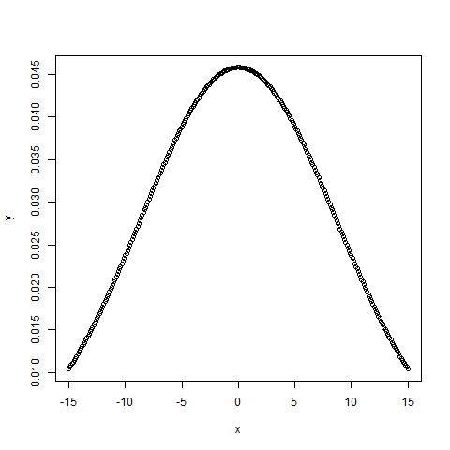 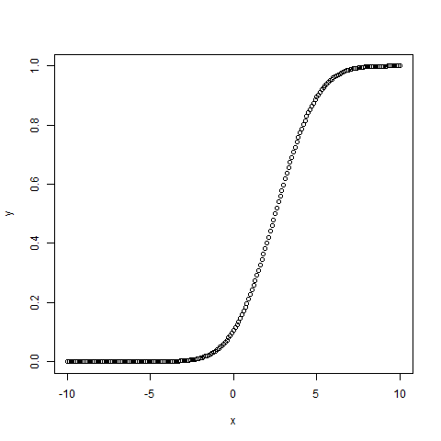

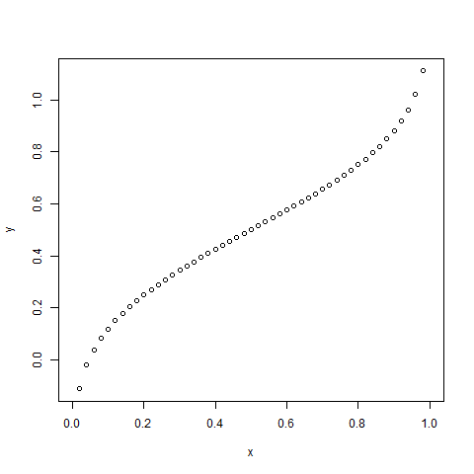 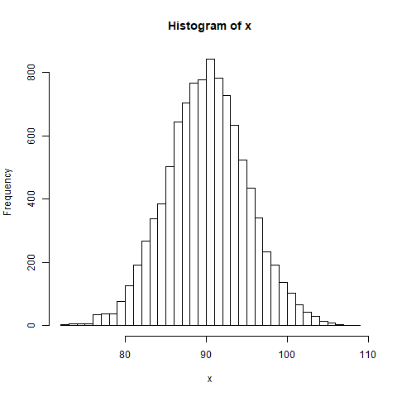

**EXPERIMENT NO:9(b) DATE:**

**AIM:** Implement R Script to perform correlation, Linear and multiple regression.

**DESCRIPTION:**

**Correlation**: is a statistical measure that indicates how strongly two variables are related. It involves the relationship between multiple variables as well. Generally, it lies between -1 and +1. It is a scaled version of covariance and provides the direction and strength of a relationship.

R Language provides two methods to calculate the pearson correlation coefficient. By using the functions cor() or cor.test() it can be calculated. It can be noted that cor() computes the correlation coefficient whereas cor.test() computes the test for association or correlation between paired samples.

**Syntax:** cor(x, y, method = “pearson”)   
cor.test(x, y, method = “pearson”)

**PROGRAM:**

x<-c(1,2,3,4,5,6,7)

y<-(1,3,6,2,7,4,5)

result=cor(x,y,method=”pearson”)

cat(“pearson correlation coefficient is :”,result)

result1=cor.test(x,y,method=”pearson”)

cat(“pearson correlation coefficient is :”,result1)

**OUTPUT:**

Pearson correlation coefficient is: 0.5357143

Pearson's product-moment correlation

data: x and y

t = 1.4186, df = 5, p-value = 0.2152

alternative hypothesis: true correlation is not equal to 0

95 percent confidence interval:

-0.3643187 0.9183058

sample estimates:

cor

0.5357143